**Western Australian Certificate of Education**

**Semester 2 Examination, 2019**

**EXAM SOLUTIONS**

Please place your student identification label in this box (if required)

**COMPUTER**

**SCIENCE**

## Year 11 ATAR: Unit 1 & 2

|  |  |  |  |  |  |  |  |  |  |  |  |  |
| --- | --- | --- | --- | --- | --- | --- | --- | --- | --- | --- | --- | --- |
| Student Number: | In figures |  |  |  |  |  |  |  |  |  |  |  |
|  | In words |  |  |  |  |  |  |  |  |  |  |  |
|  |  |  |  |  |  |  |  |  |  |  |  |  |

## Time allowed for this paper

Reading time before commencing work: ten minutes

Working time: three hours

## Materials required/recommended for this paper

***To be provided by the supervisor***

This Question/Answer booklet

Source booklet

***To be provided by the candidate***

Standard items: pens, pencils, eraser, correction fluid/tape, ruler, highlighters

Special items: non-programmable calculators approved for use in this examination, Mathomat and/or Mathaid and/or any system flowchart template

**Important note to candidates**

No other items may be taken into the examination room. It is **your** responsibility to ensure that you do not have any unauthorised material. If you have any unauthorised material with you, hand it to the supervisor **before** reading any further.

## Structure of this Paper

|  |  |  |  |  |  |
| --- | --- | --- | --- | --- | --- |
| Section | Number of questions available | Number of questions to be answered | Suggested working time (minutes) | Marks available | Percentage of examination |
| Section One:  Short answer | 20 | 20 | 70 | 78 | 40 |
| Section Two:  Extended answer | 4 | 4 | 110 | 122 | 60 |
|  |  |  |  | **Total** | 100 |

## Instructions to candidates

1. The rules for the conduct of the Western Australian Certificate of Education ATAR course examinations are detailed in the *Year 12 Information Handbook 2019*. Sitting this examination implies that you agree to abide by these rules.
2. Write your answers in the spaces provided in this Question/Answer booklet. A blue or black pen should be used. Wherever appropriate, fully labelled diagrams, tables and examples should be used to illustrate and support your answers.
3. You must be careful to confine your answers to the specific questions asked and to follow any instructions that are specific to a particular question. Where no specific instructions are given, you should feel free to use a range of formats to express your knowledge and understandings.
4. Additional working space pages at the end of this Question/Answer booklet are for planning or continuing an answer. If you use these pages, indicate at the original answer, the page number it is planned/continued on and write the question number being planned/continued on the additional working space page.

## Section One: Short answer 40% (78 marks)

This section contains **twenty (20)** questions. You must answer **all** questions. Write your answers in the spaces provided.

Supplementary pages for the use of planning/continuing your answer to a question have been provided at the end of this Question/Answer booklet. If you use these pages to continue an answer, indicate at the original answer where the answer is continued, i.e. give the page number.

Suggested working time: 70 minutes.

1. (2 marks)

Outline the difference between RAM and ROM.

|  |  |
| --- | --- |
| **Description** | **Mark** |
| Outlines the difference | 2 |
| Defines RAM and/or ROM | 1 |
| **Total** | **2** |
| Sample answer:  RAM (Random Access Memory) is primary storage, volatile, working memory for the Central Processing Unit. RAM is the hardware in a computing device where the operating system (OS), application programs and data in current use are kept so they can be quickly reached by the device's processor. ROM (Read Only Memory), primary memory, non-volatile, used to store the system’s firmware or the BIOS (Basic Input Output System). | |
| Accept other answers | |

1. (1 mark)

State the type of authentication that uses physiological or behavioural characteristics.

|  |  |
| --- | --- |
| **Description** | **Mark** |
| Biometrics | 1 |
| **Total** | **1** |
| Answer - Biometrics  Biometrics authentication is used in computer science as a form of identification it refers to metrics related to human characteristics. Examples include, but are not limited to fingerprint, palm veins, face recognition, DNA, hand geometry, iris recognition, retina and odour/scent. | |
| Accept other answers | |

1. (4 marks)

The HP Pavilion All-in-One desktop personal computer has the following specifications:

Intel® Core™ i5-8400T   
8GB RAM  
1TB HDD storage  
NVIDIA GeForce MX130 graphics (2GB GDDR5)  
FHD BrightView WLED-backlit touch screen (1920 x 1080)  
HP Truevision FHD IR camera with dual array digital microphone  
Wireless keyboard and mouse

Identify a hardware component from the above computer system designed for the following specific purpose:

Input

Output

Processing

Primary storage

|  |  |
| --- | --- |
| **Description** | **Mark** |
| For each of the **four** purposes | |
| Identifies correct hardware component | 1 |
| **Total** | **4** |
| Sample Answer:  Input: Wireless keyboard, mouse, camera, microphone, touch screen (accept any)  Output: Touch screen  Processing: Intel® Core™ i5-8400T  Primary storage: 8GB RAM | |

1. (6 marks)

Describe the function of the following components in the central processing unit (CPU).

Control unit

Arithmetic logic unit (ALU)

System clock

|  |  |
| --- | --- |
| **Description** | **Mark** |
| For each of the **four** purposes | |
| Outlines the function of the component | 2 |
| Identifies aspects of the component | 1 |
| **Total** | **6** |
| Sample answer:  Control Unit: The CU directs and coordinates most of the operations of the CPU. It tells the computer's memory, arithmetic and logic unit and input and output devices how to respond to the instructions that have been sent to the processor.  Arithmetic Logic Unit (ALU): Performs all arithmetic operations like addition, subtraction, division and multiplication and logical operations of the computer system.  System Clock: Issues a steady high-frequency signal that synchronises all the internal components of the computer system including the CPU. | |
| Accept other answers | |

1. (5 marks)

Outline the steps of the boot process from power up to OS booting.

|  |  |
| --- | --- |
| **Description** | **Mark** |
| For each of the **five** sections below | |
| Outlines the main actions that occur in the section of the boot process  *Note – there is no need to include the titles below as these are not mandated – the processes within each section is what this question requires | 1 |
| **Total** | **5** |
| Sample answer:  **Power Up** - The power button activates the power supply in the PC, sending power to the motherboard and other components.  **Power On Self Test** - The PC performs a power-on self-test (POST). The POST is a small computer program within the BIOS that checks for hardware failures and compares components with last know configuration.  **Find a Boot Device** - The BIOS (basic-input-output-system) is software stored on a flash memory chip ROM or read only memory. In a PC, the BIOS is embedded on the motherboard. The BIOS confirms there's a boot loader in secondary storage, then it loads that boot loader into memory (RAM).  **Load the operating system** - This boot loader finds the operating system and loads it into memory.  **Transfer control** - Once the OS is in memory it takes control and loads applications and user preferences. | |
| Accept other answers | |

1. (3 marks)

Use the image below to answer the following questions about spreadsheet functions.

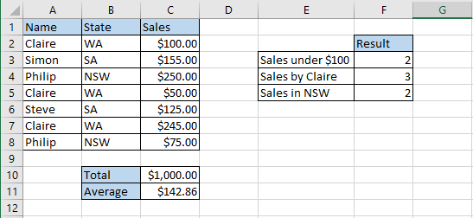

State the formula that would be contained in the following cells:

C10

C11

F3

|  |  |
| --- | --- |
| **Description** | **Mark** |
| For each of the **three** cells | |
| Correct formula for each cell | 1 |
| **Total** | **3** |
| Sample Answer:  C10: =SUM(C2:C8)  C11: =AVERAGE(C2:C8)  F3: =COUNTIF(C2:C8, “<100”) | |

1. (3 marks)

Define the following database terms:

Relation

Data integrity

Data redundancy

|  |  |
| --- | --- |
| **Description** | **Mark** |
| For each of the **three** terms | |
| Correctly defined terms | 1 |
| **Total** | **3** |
| Sample Answer:  Relation: A table within a (relational) database.  Data integrity: Relates to the accuracy and consistency of the data.  Data redundancy: Duplication of the same attributes in a table; attribute data that can be derived from other existing data. | |

1. (6 marks)

A problem exists in this entity relationship diagram (ERD). Illustrate how you would resolve this issue in the space below. Show only entities, relationships, cardinality, primary and foreign keys. No non-key attributes are needed.

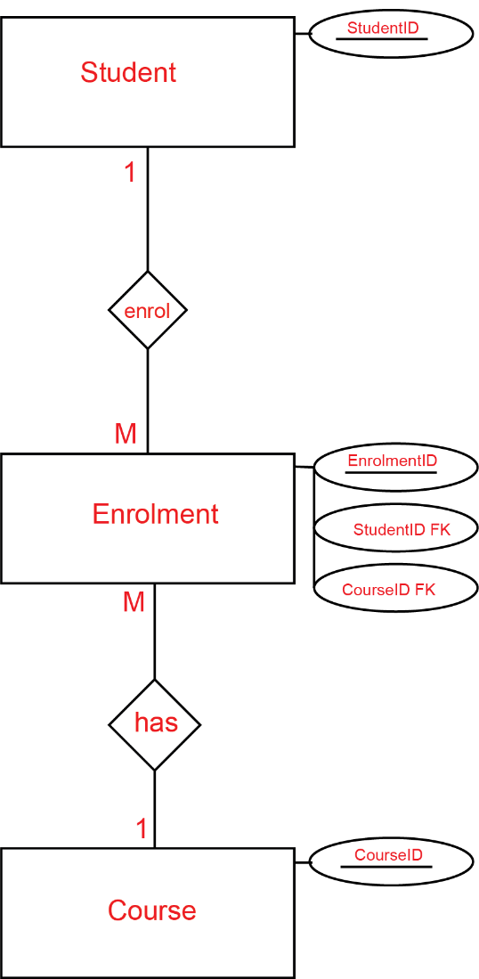

|  |  |
| --- | --- |
| **Description** | **Mark** |
| **Entities** | |
| Student, enrolment (or student/course) and course | 1 |
| **Primary Keys** | |
| StudentID, EnrolmentID and CourseID | 1 |
| **Foreign Keys** | |
| StudentIDFK, and CourseIDFK | 1 |
| **Cardinality** | |
| Student 🡪 Enrolment - 1:M  Enrolment 🡪 Course - M:1 | 1  1 |
| **Relationships** | |
| enrol or has (name may vary) | 1 |
| **Total** | **6** |

1. (6 marks)

Describe the purpose of the following types of software and give an example for each.

Operating system

Example:

Utility software

Example:

|  |  |
| --- | --- |
| **Description** | **Mark** |
| For each of the **two** types of software | |
| Describes the purpose of the type of software | 2 |
| Identifies aspect of the purpose of the type of software | 1 |
| **Subtotal** | **4** |
| Provides an example of the type of software | 1 |
| **Subtotal** | **2** |
| **Total** | **6** |
| Sample Answer:  Operating System: Is software which operates or performs the core tasks required of the computer, controlling all hardware and peripherals and making all components perform their functions. The OS provides a base on which all other types of software can execute.  Examples: Microsoft Windows, MacOS, Linux, Android, iOS (accept others)  Utility Software: Performs the maintenance related tasks on computer hardware. Usually to improve system’s performance.  Examples: File compression, defragmentation, anti-virus and anti-malware software. | |

1. (3 marks)

Explain the difference between freeware and open source software licences.

|  |  |
| --- | --- |
| **Description** | **Mark** |
| Explains the difference between freeware and open source software licences | 3 |
| Supplies some relevant facts about freeware and open source software licences | 2 |
| Makes superficial comment(s) about freeware and open source software licences | 1 |
| **Total** | **3** |
| Sample Answer:  Freeware software licenses have been written by a programmer(s) who has made it available for free for use and download. This does not mean the software can be modified, distributed or copied. Open source software is available similar to freeware however, the source code is also available for modification. | |

1. (4 marks)

The Dataflow Diagram below has several errors. Outline **four** errors in the diagram.

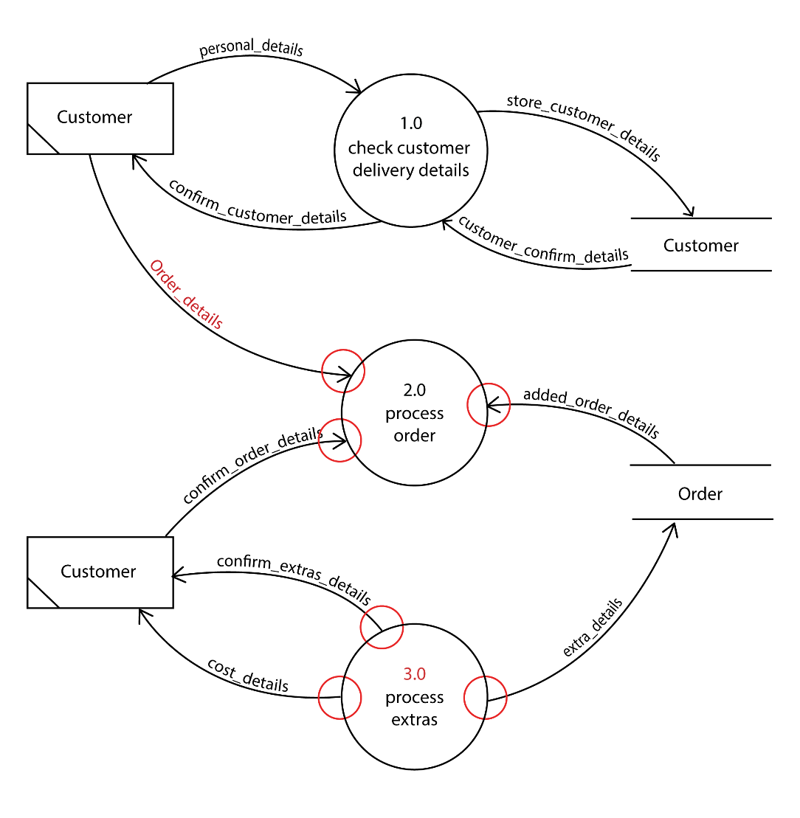

|  |  |
| --- | --- |
| **Description** | **Mark** |
| For each of the **four** errors | |
| Errors highlighted or annotated | 1 |
| **Total** | **4** |
| Sample Answer:  Data Flow Order_details was NOT labelled.  Process Order does NOT have any data flows leaving the process.  Process extras process not numbered  Process extras process only has outflows and no inflows (miracle). | |

1. (1 mark)

State **one** reason for appropriately naming a variable in your code.

|  |  |
| --- | --- |
| **Description** | **Mark** |
| States reason for appropriately naming variables | 1 |
| **Total** | **1** |
| Sample Answer:  Readability. Good variable names accurately describe their purpose.  Reduce the effort needed to read and understand source code.  Extremely short variable names i.e. x,a or i are difficult to uniquely distinguish.  Really long variable names create visual clutter. | |
| Accept other answers | |

1. (2 marks)

Describe the reason a programmer would use a test first iteration over a test last iteration.

|  |  |
| --- | --- |
| **Description** | **Mark** |
| Describes the reason for using test first over test last | 2 |
| Identifies aspects test first or test last loops | 1 |
| **Total** | **2** |
| Sample Answer:  A test first may execute the loop zero times whereas a test last loop must execute the loop at least once. | |
| Accept other answers | |

1. (3 marks)
2. Convert the following binary number to a decimal number. (1 mark)

01101100 Base 2

|  |  |
| --- | --- |
| **Description** | **Mark** |
| 108 | 1 |
| **Total** | **1** |
| Answer:  1x64+1x32+1x8+1x4=108 | |

1. Convert the following hexadecimal number to a decimal number. (1 mark)

23B Base 16

|  |  |
| --- | --- |
| **Description** | **Mark** |
| 571 | 1 |
| **Total** | **1** |
| Answer:  2x256+3x16+11x1=571 | |

1. Convert the following decimal number to a binary number. (1 mark)

178 Base 10

|  |  |
| --- | --- |
| **Description** | **Mark** |
| 10110010 | 1 |
| **Total** | **1** |
| Answer:  1x128+1x32+1x16+1x2=10110010 | |

1. (6 marks)

Describe the function of the following network components:

Router

Switch

Modem

|  |  |
| --- | --- |
| **Description** | **Mark** |
| For each of the **three** networking components | |
| Describes the purpose of the networking component | 2 |
| Identifies aspect of the purpose of the networking component | 1 |
| **Total** | **6** |
| Sample Answer:  Router: Connects two or more network types together, it forwards packets based on network level addresses (Internet Protocol addresses).  Switch: Connects multiple computers in a network together and intelligently learns which devices are connected to its ports, a switch reduces the amount of data on the network.  Modem: (Modulator-Demodulator) Converts a digital signal from a computer to an analogue signal that can be transmitted along an ordinary phone line. | |

1. (6 marks)

Describe the following transmission media and give an advantage for its use.

Wireless

Advantage

Fibre Optic

Advantage

|  |  |
| --- | --- |
| **Description** | **Mark** |
| For each of the **two** networking components | |
| Describes the characteristics of the transmission media | 2 |
| Identifies aspect of the characteristics of the transmission media | 1 |
| **Subtotal** | **4** |
| Identifies an advantage for the transmission media | 1 |
| **Subtotal** | **2** |
| **Total** | **6** |
| Sample Answer:  Wireless: Wireless or use radio waves (electromagnetic waves) of different frequencies to carry a signal and do not need a wire or cable conductor to transmit signals.  Possible advantages: do not need a wire or cable conductor to transmit signals, multiple devices can connect at one time, portability and flexibility as devices can move within an area. Relatively cheap to purchase wireless enabled devices and installation doesn’t require a technically skilled  Individual.  Fibre Optic: Guided transmission of data as pulses of light through a strand or fibre medium made of glass or plastic (optical fibre), versus being sent as electrical pulses through conductive metal, like copper wires.  Possible advantages: Bandwidth, amount of data that can be transmitted over time is significantly higher than copper or wireless transmission. Immune to electromagnetic interference. Very secure. | |

1. (2 marks)

Ethernet has become the most popular and widely deployed Local Area Network (LAN) technology in the world. State **two** reasons for this.

|  |  |
| --- | --- |
| **Description** | **Mark** |
| For each of the **two** reasons | |
| States reason for Ethernet becoming popular | 1 |
| **Total** | **2** |
| Sample Answer:  The IEEE Ethernet 802.3 standard meant that any company could produce devices to connect to the network if they followed the standard.  Ethernet enabled devices are relatively cheap to purchase.  Ethernet cables and connectors are relatively cheap and easy to install.  Ethernet has continued to increase in speed as required by technology users. | |
| Accept other answers | |

1. (6 marks)

Expand the acronym and describe the purpose of the following types of communication protocols.

The first one has been done for you.

HTTP: *Hypertext Transfer Protocol*

Purpose: *HTTP protocol specifies how client’s request data will be constructed and sent to the server and how the server respond to these requests.*

FTP

Purpose

SMTP

Purpose

|  |  |
| --- | --- |
| **Description** | **Mark** |
| For each of the **two** communication protocols | |
| Expand the acronym correctly for the communication protocols | 1 |
| **Subtotal** | **2** |
| Describes the purpose of the communication protocols | 2 |
| Identifies aspect of the purpose of the communication protocols | 1 |
| **Subtotal** | **4** |
| **Total** | **6** |
| Sample Answer:  FTP: File Transfer Protocol – FTP is used to transfer computer files from one host to another host over TCP-based network, such as the Internet. Based on a client-server architecture.  SMTP: Simple Mail Transfer Protocol - SMTP is an Internet standard for sending electronic mail transmission. It is a set of commands that authenticate and directs the transfer of email. | |

1. (2 marks)
2. State one ethical responsibility of software developers. (1 mark)

|  |  |
| --- | --- |
| **Description** | **Mark** |
| States ethical responsibility of software developers | 1 |
| **Total** | **1** |
| Sample Answer:  Ethical responsibility of software developers could include;  Contribute to society and human well-being.  Avoid harm to others.  Be honest and trustworthy.  Give proper credit for intellectual property.  Respect the privacy of others.  Honour confidentiality. | |
| Accept other answers | |

1. State one ethical responsibility of software users. (1 mark)

|  |  |
| --- | --- |
| **Description** | **Mark** |
| States ethical responsibility of software users | 1 |
| **Total** | **1** |
| Sample Answer:  Ethical responsibility of software users could include;  Unauthorised use of computers and networks.  Software piracy.  Information accuracy.  Intellectual property rights.  Codes of conduct.  Information privacy. | |
| Accept other answers | |

1. (7 marks)

Use the image below to answer all parts of this question about databases.  
  
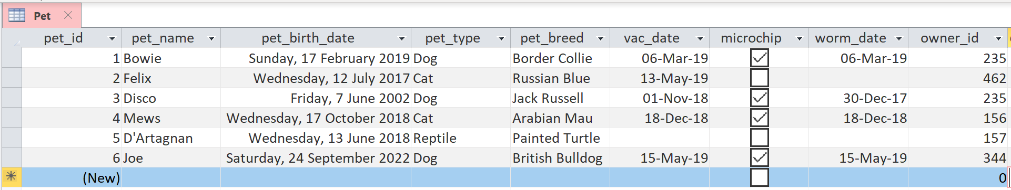

1. Identify which data type you would use for the following: (3 marks)

pet_id

pet_type

microchip

|  |  |
| --- | --- |
| **Description** | **Mark** |
| For each of the **three** fields | |
| Identifies the correct data type | 1 |
| **Total** | **3** |
| Sample Answer:  pet_id: number (auto-number)  pet_type: text (string)  microchip: boolean (true/false) | |

1. In the pet_birth_date field an obvious data entry error has been made. Identify the error. (1 marks)

|  |  |
| --- | --- |
| **Description** | **Mark** |
| Pet_id 6 birthday is in the future Saturday, 24 September 2022. | 1 |
| **Total** | **1** |

1. State a validation rule that could be used to avoid this issue. (1 marks)

|  |  |
| --- | --- |
| **Description** | **Mark** |
| Pet_birth_date >=Date() | 1 |
| **Total** | **1** |
| Accept other answers | |

1. The Central Vet Clinic would like to develop some software to manage pet bookings. State two factors affecting the development of software. (2 marks)

|  |  |
| --- | --- |
| **Description** | **Mark** |
| For each of the **two** factors | |
| States correct factors affecting the development of software | 1 |
| **Total** | **3** |
| Sample Answer:  User needs – what is the stimulus for creating the software, weakness with the current system, pain points, is there an opportunity or competitive advantage, threat or legislation to keep up with.  User interface – How will the user interact with the system, will the software be mobile or web based, what makes a good user interface, ease of use, access to required information. | |
| Accept other answers | |

**END OF SECTION ONE**

## Section Two: Extended Answer 70% (122 Marks)

This section has **four (4)** questions. Answer all questions. Write your answers in the spaces

provided.

Supplementary pages for the use of planning/continuing your answer to a question have been provided at the end of this Question/Answer booklet. If you use these pages to continue an answer, indicate at the original answer where the answer is continued, i.e. give the page number.

Suggested working time: 110 minutes.

1. (36 marks)

Refer to the Source booklet to answer this question.

* 1. The Central Vet Clinic have begun planning their new system. A system analyst suggested they use the system development life cycle (SDLC) as a development methodology. Identify the first two stages of the SDLC and describe what happens in each stage. (6 marks)

First Stage

Description

Second Stage

Description

|  |  |
| --- | --- |
| **Description** | **Mark** |
| For each of the **two** stages | |
| Correctly identifies stage | 1 |
| **Subtotal** | **2** |
| Describes the activities in the stage of the SDLC | 2 |
| Identifies an aspect of activities in the stage of the SDLC | 1 |
| **Subtotal** | **4** |
| **Total** | **6** |
| Sample Answer:  First two stages - preliminary analysis and analysis.  Preliminary analysis: The existing system is evaluated. Deficiencies are identified. This can be done by interviewing users of the system and consulting with support personnel. Problem definition and evaluating if the project is feasible. Will the benefits outweigh the costs?  Analysis: The new system requirements are defined. In particular, the deficiencies in the existing system must be addressed with specific proposals for improvement. Modelling of the current system to identify the requirements of the new system. | |
| Accept other answers | |

* 1. A project manager discussed the concepts of planning, scheduling, budgeting and tracking. Describe why it is important to track a project’s progress. (2 marks)

|  |  |
| --- | --- |
| **Description** | **Mark** |
| Describes the importance of tracking | 2 |
| Identifies an aspect of planning, scheduling, budgeting and tracking | 1 |
| **Total** | **2** |
| Sample Answer:  Tracking requires regular review of the project progress. Measuring and reporting the status of milestones. Variances from the original plan are identified and managed to keep the project within scope, on time, and within budget. Failure to track and plan for variances will reduce the project’s success of keeping within scope, time and budget. | |
| Accept other answers | |

* 1. Use the source booklet to complete the unfinished Context Diagram for the Central Vet Clinic appointment system below. (11 Marks)

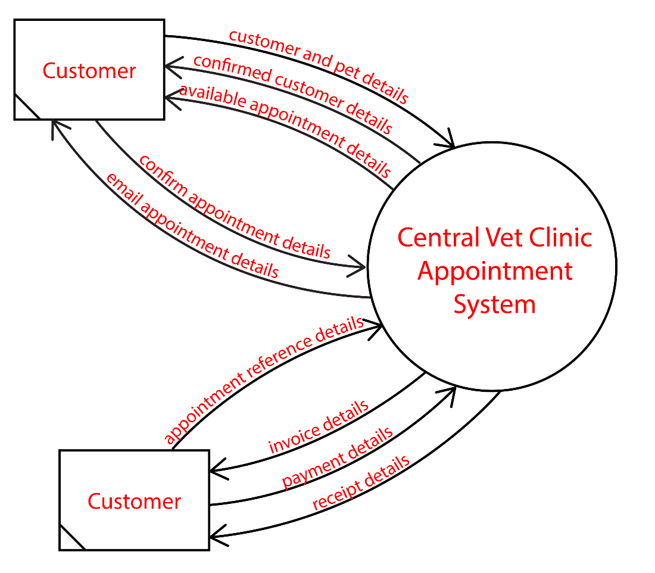

|  |  |
| --- | --- |
| **Description** | **Mark** |
| **System** | |
| The Central Vet Clinic Appointment System | 1 |
| **External Entity** | |
| * Customer | 1 |
| **Data Flows** | |
| Data Flows from customer entity to system – 1 mark each   * Customer and pet details, confirm appointment details, appointment reference details and payment details. | 4 |
| Data flows from system to customer entity – 1 mark each   * Confirmed customer details, available appoitment details, email appointment details, invoice details and receipt details. | 5 |
| **Total** | **11** |
| System must end if the word ‘system’  Preferable that data flows end in the word ‘details’ (marker’s discretion) | |

* 1. Use the source booklet to create the Level 0 Data Flow Diagram (DFD) for the system below. (17 Marks)

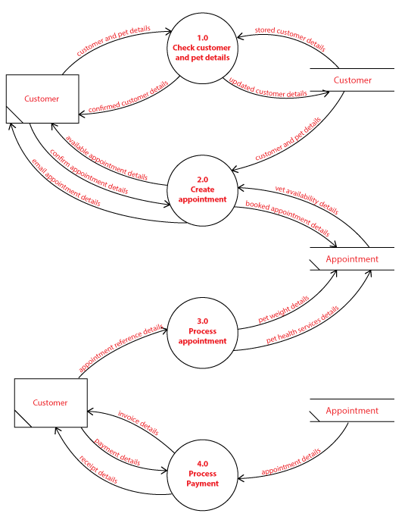

|  |  |
| --- | --- |
| **Description** | **Mark** |
| **Processes** | |
| 1. Check customer and pet details 2. Create appointment 3. Process appointment 4. Process payment | 1  1  1  1 |
| Accept other relevant answers.  Processes must start with a verb.  Must include numbering (numbers do not have to correspond to those in the marking key but must not be the same as those already provided). | |
| **Subtotal** | **4** |
| **External Entity** | |
| * Customer | 1 |
| **Subtotal** | **1** |
| **Data Stores** | |
| * Customer * Appointment | 1  1 |
| **Subtotal** | **2** |
| **Data Flows** | |
| Process 1.0 – Check customer and pet details  Inflows – customer and pet details, stored customer (and pet) details – 1 mark  Outflows – updated customer (and pet) details, confirmed customer details – 1 mark | 2 |
| Process 2.0 – Create appointment  Inflows –customer and pet details, vet availability details, confirm appointment details  – 1 mark  Outflows – Available appointment details, booked appointment details, email appointment details – 1 mark | 2 |
| Process 3.0 – Process appointment  Inflows – appointment reference details – 1 mark  Outflows – pet weight details, pet health services details– 1 mark | 2 |
| Process 4.0 – Process payment  Inflows –appointment details, payment details – 1 mark  Outflows – invoice details, receipt details – 1 mark | 2 |
| Accept other relevant answers.  Preferable that data flows end in the word ‘details’ (marker’s discretion) | |
| **Subtotal** | **8** |
| **Extras** | |
| Correct use of Yourdon/DeMarco notation  Balanced context and level 0 DFD | 1  1 |
| **Subtotal** | **2** |
| **Total** | **17** |

Use the source booklet to **answer the following question** for the Central Vet Clinic.

1. (21 marks)
   1. Complete the Entity Relationship (ER) Diagram for this database in the area below using Chen’s notation. Ensure you resolve all many to many relationships. Include Primary keys, Foreign keys, cardinality and relationships. You do not need to include non-key fields. (14 marks)

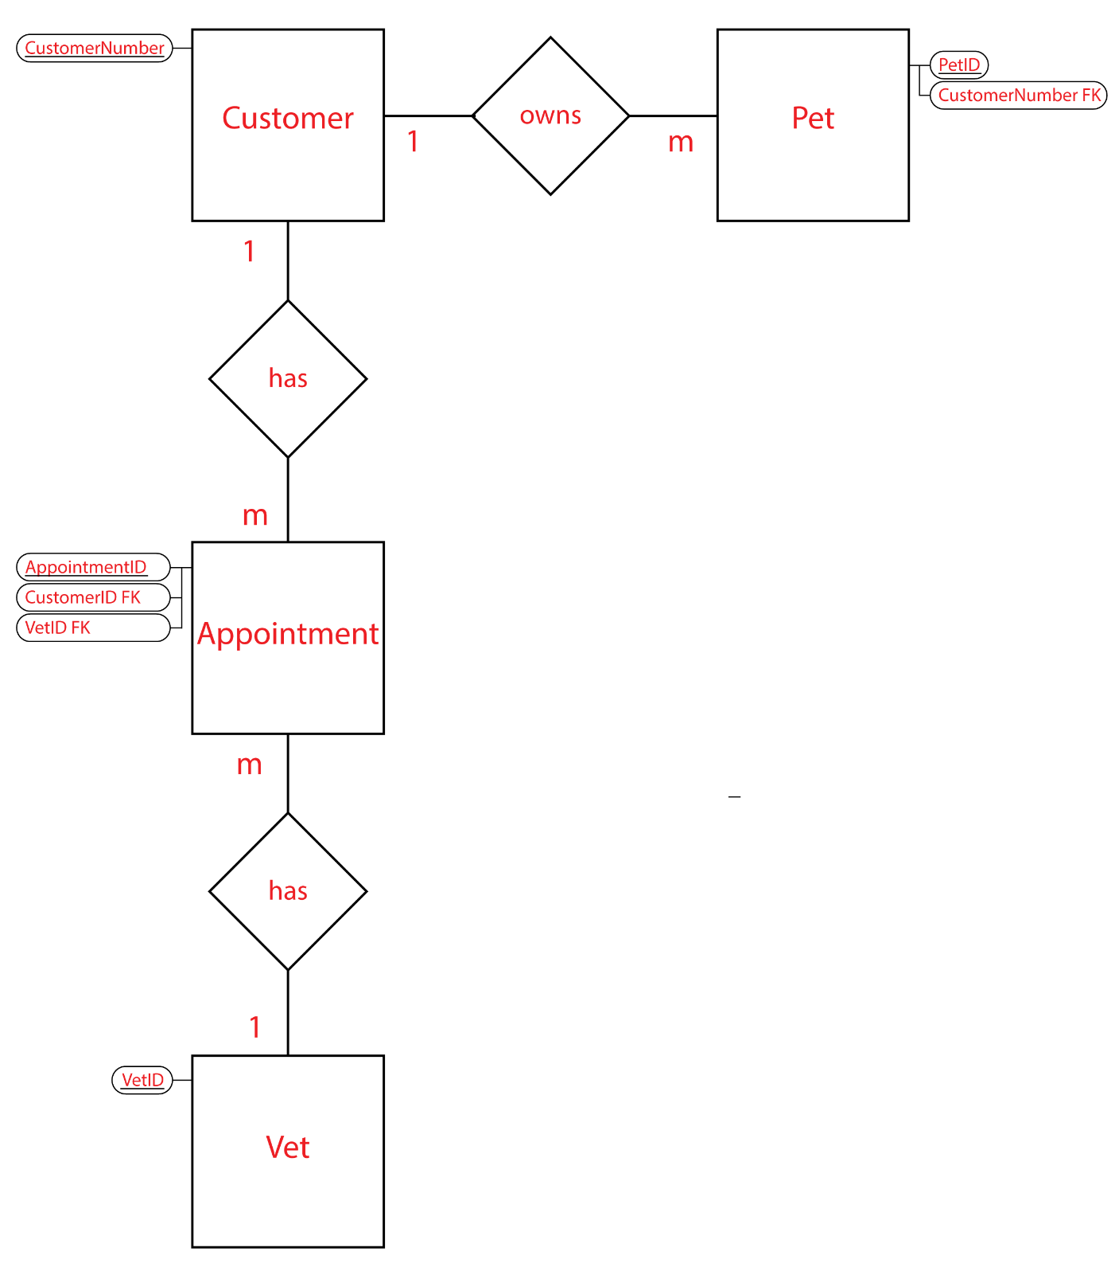

|  |  |
| --- | --- |
| **Description** | **Mark** |
| **Entities** | |
| Customer  Pet  Appointment (or Customer/vet)  Vet | 1  1  1  1 |
| **Subtotal** | **4** |
| **Primary Keys** | |
| Customer entity – CustomerNumber  Pet entity – PetID  Appointment entity–AppointmentID (may use CustomerNumber/Vet but must also include date and time as part of composite PK to make it unique)  Vet entity - VetID | 1  1  1  1 |
| **Subtotal** | **4** |
| **Foreign Keys** | |
| Pet entity – CustomerNumber FK  Appointment Entity – CustomerNumber FK, Vet FK | 1  2 |
| **Subtotal** | **3** |
| **Cardinality** | |
| Customer 🡪 Pet– 1:m  Customer 🡪 Appointment– 1:m  Appointment 🡪 Vet– m:1 | 1  1  1 |
| **Subtotal** | **3** |
| **Total** | **14** |

* 1. State one benefit of using a relational database to store The Central Vet Clinic’s data.

(1 mark)

|  |  |
| --- | --- |
| **Description** | **Mark** |
| States benefit for relational database | 1 |
| **Total** | **1** |
| Sample Answer:  Reducing Data Redundancy – single location for data i.e. one record in the Customer table.  Sharing of data – simultaneous access of the data for all Vet employees.  Data Integrity – improved accuracy and consistency of the data as it is entered in a single record.  Privacy – levels of access can be granted to ensuring only authorised people have access to the required records/tables. | |
| Accept other answers | |

Use the image below to answer this next question.

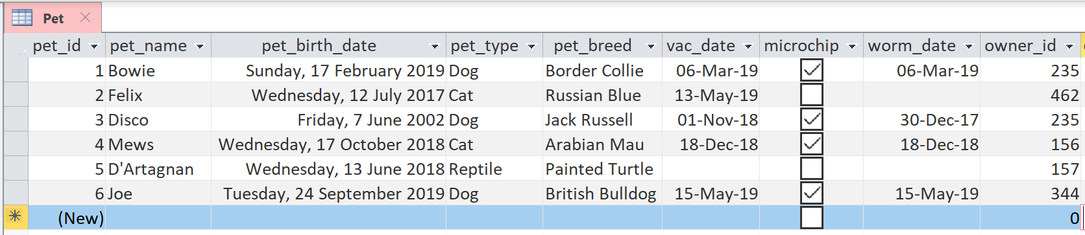

* 1. Refer to the Pet table, using Structured Query Language (SQL), write a query that will return all fields from the Pet table which have been microchipped. (3 marks)

|  |  |
| --- | --- |
| **Description** | **Mark** |
| SELECT * | 1 |
| FROM Pet | 1 |
| WHERE microchip=’true’; | 1 |
| **Total** | **3** |

* 1. Refer to the Pet table, using Structured Query Language (SQL), write a query that will return the pet’s name, type of pet and date of birth fields if the pet is a dog from the Pet table. (3 marks)

|  |  |
| --- | --- |
| **Description** | **Mark** |
| SELECT pet_name, pet_type, pet_birth_date | 1 |
| FROM Pet | 1 |
| WHERE pet_type=’Dog’; | 1 |
| **Total** | **3** |

1. (39pay marks)

When animals arrive at the Central Vet Clinic for their appointment, they are weighed so that the vet knows dosage for medication. Unfortunately, the software the clinic is using is from overseas and only allows staff to input weights using pounds and not kilograms.

The clinic has asked that you create an algorithm which will provide a conversion from kilograms to pounds so that they can enter the weight in pounds into the system. The formula to convert from kilograms to pounds is:

Weight(pounds) = weight(kilograms) * 2.20462262185

Hint: the international standard symbol for pounds is lb

* 1. Use pseudocode to design an algorithm to convert the pet weight measured in kilograms to a pet weight in pounds.

Your algorithm should: (9 marks)

* + - input the appointment reference number (appointmentRefNum)
    - input the pet’s name (petName)
    - input the pet weight in kg (petWeightKg)
    - check to ensure the weight is a valid number (above 0kg and less than 200kg)
    - output an error message if an invalid number is entered
    - convert the pet weight to pounds (petWeightLb)
    - output the appointment reference number and the pet weight in pounds   
      (eg. Fido weighs 250lb)

|  |  |
| --- | --- |
| **Description** | **Mark** |
| Begin and End | 1 |
| input(appointmentRefNum) | 1 |
| input(petName) | 1 |
| input(petWeightKg) | 1 |
| If (petWeightKg <= 0) or (petWeightKg >=200) then | 2 |
| output(‘Please enter a valid weight greater than 0 and less than 200kg’) | 1 |
| petWeightLb 🡨 petWeightKg * 2.20462262185 | 1 |
| output(petName, ‘ weighs ‘,petWeightLb,’lb’) | 1 |
| **Total** | **9** |
| **Sample answer:**  Begin  input(appointmentRefNum)  input(petName)  input(petWeightKg)  If (petWeightKg <= 0) or (petWeightKg >=200) then  output(‘Please enter a valid weight greater than 0 and less than 200kg’)  End if  petWeightLb 🡨 petWeightKg * 2.20462262185  output(petName, ‘ weighs ‘,petWeightLb,’lb’)  End | |
| Accept other answers as long as it still performs the calculation appropriately | |

Use the source booklet to **answer the following question** for the Central Vet Clinic.

* 1. Complete the following flowchart using the algorithm on page 4 of the source booklet. (10 marks)

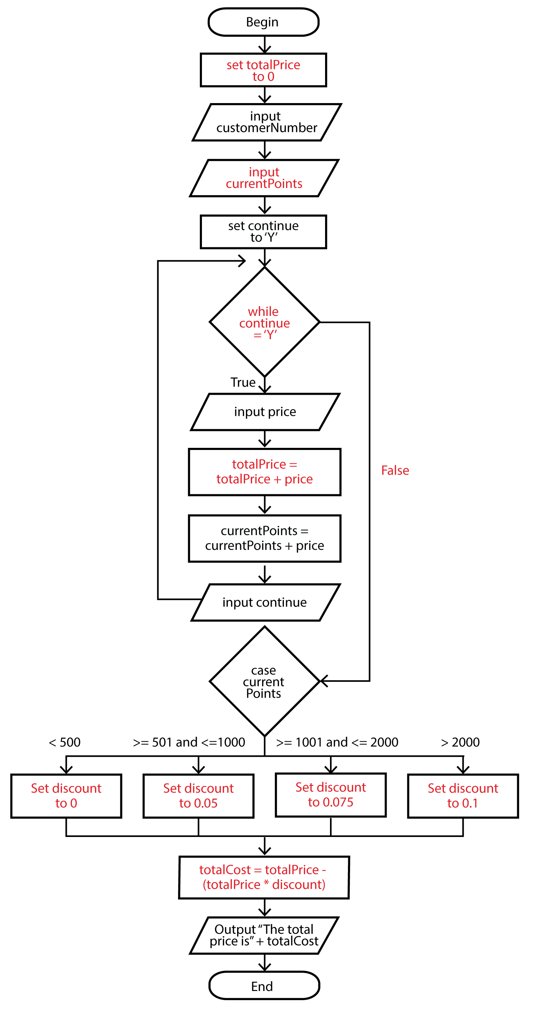

|  |  |
| --- | --- |
| **Description** | **Mark** |
| One mark per correct label | 1 |
| **Total** | **10** |
| Labels may vary slightly | |

* 1. Use the data in the table below to test the algorithm from question 23(b).

|  |  |  |  |
| --- | --- | --- | --- |
| **Customer Number** | **Current Points** | **Appointment details** | **Price** |
| 2822 | 150 | Sterilisation  Worming | 360  40 |

Complete the following trace table. Part of it has been completed for you. **(13 marks)**

|  |  |  |  |  |  |  |  |  |  |
| --- | --- | --- | --- | --- | --- | --- | --- | --- | --- |
| **Line No** | **total Price** | **customer Number** | **current Points** | **continue** | **Continue = ‘Y’** | **price** | **discount** | **Total Cost** | **Output** |
| 1 | 0 |  |  |  |  |  |  |  |  |
| 2 |  | 2822 |  |  |  |  |  |  |  |
| 3 |  |  | 150 |  |  |  |  |  |  |
| 4 |  |  |  | Y |  |  |  |  |  |
| 5 |  |  |  |  | TRUE |  |  |  |  |
| 6 |  |  |  |  |  | 360 |  |  |  |
| 7 | 360 |  |  |  |  |  |  |  |  |
| 8 |  |  | 510 |  |  |  |  |  |  |
| 9 |  |  |  | Y |  |  |  |  |  |
| 5 |  |  |  |  | TRUE |  |  |  |  |
| 6 |  |  |  |  |  | 40 |  |  |  |
| 7 | 400 |  |  |  |  |  |  |  |  |
| 8 |  |  | 550 |  |  |  |  |  |  |
| 9 |  |  |  | N |  |  |  |  |  |
| 5 |  |  |  |  | FALSE |  |  |  |  |
| 13 |  |  |  |  |  |  | 0.075 |  |  |
| 17 |  |  |  |  |  |  |  | 370 |  |
| 18 |  |  |  |  |  |  |  |  | The total price is $370 |

|  |  |
| --- | --- |
| **Description** | **Mark** |
| One mark per correct full line | 1 |
| **Total** | **13** |

* 1. The Central Vet Clinic don’t understand the purpose of internal documentation. Describe this term and suggest who might use it. (3 marks)

Purpose

User

|  |  |
| --- | --- |
| **Description** | **Mark** |
| Describes the purpose of internal documentation | 2 |
| Supplies some relevant facts about internal documentation | 1 |
| **Subtotal** | **2** |
| Identifies user | 1 |
| **Subtotal** | **1** |
| **Total** | **3** |
| Sample Answer:  Internal documentation is a set of non-executable human-readable comments inserted into programming source code to make it easier to understand.  Who would use internal documentation? Solo programmer to remind them of what they were thinking when they created the algorithm. Programming teams or peer programming where someone writes the code and another person checks it. Internal documentation helps to clarify the intent of the piece of code. | |

* 1. When testing some code at The Central Vet Clinic, it returned a run-time error. State one cause of such and error. (1 marks)

|  |  |
| --- | --- |
| **Description** | **Mark** |
| Correctly stated cause of error. | 1 |
| **Total** | **1** |
| Sample Answer:  Common examples of errors that cause a run-time error are;  Trying to divide by a variable that contains a value of zero.  Trying to open a file that doesn't exist. | |

* 1. A system analyst suggested the Vet Clinic’s new system should be developed using an object-oriented programming language. (3 marks)

i. Identify one object-oriented language. (1 marks)

|  |  |
| --- | --- |
| **Description** | **Mark** |
| Correctly identifies an object-oriented language | 1 |
| **Total** | **1** |
| Sample Answer:  Common object-oriented languages include;  Java, JavaScript., Python, C++, Visual Basic .NET, Ruby, PHP | |

ii. State two benefits for using an object-oriented language. (2 marks)

|  |  |
| --- | --- |
| **Description** | **Mark** |
| For each of the **two** benefits | |
| Correctly outlines benefits of using object-oriented language. | 1 |
| **Total** | **2** |
| Sample Answer:  Modules are created separately and therefore more easily troubleshooted and tested.  Reuse of code through inheritance.  Software can be written to solve one problem at a time — one object at a time.  Multiple coders can work on the software at the same time if it is broken up into different modules or objects.  Classes may be written that encompass | |
| Accept other answers | |

Use the source booklet to **answer the following question** for the Central Vet Clinic.

1. (26 marks)

The Central Vet Clinic have access to the internet and are upgrading their network to include the ability for the staff to enter appointment details about the pets on mobile tablet devices.

They have the following hardware network components:

* Firewall
* Router
* Modem
* Switch
* Wireless access point
* Wired network printer
* Network attached storage
* Desktop computer
* 4 x Tablet devices
  1. Use the space below to create a network diagram for The Central Vet Clinic.

(10 marks)

|  |
| --- |
|  |

|  |  |
| --- | --- |
| **Description** | **Mark** |
| Internet symbol (cloud) | 1 |
| Modem – correct icon used and must be hard wired (solid line) to internet (cloud) and firewall or router. | 1 |
| Firewall – correct icon used and must be hard wired (solid line) to modem and router. Also accept firewall placed after router – ie hardwired to switch and router. | 1 |
| Router – correct icon used and must be hard wired (solid line) to firewall and switch. Also accept router placed before firewall – ie hardwired to modem and firewall. | 1 |
| Switch – correct icon used and must be hardwired to router (or firewall as described above) | 1 |
| NAS Server – correct icon used (should look like a server possibly with NAS written on it) and must be hardwired directly to switch | 1 |
| Network printer - correct icon used and must be hardwired directly to switch | 1 |
| Wireless – correct icon used and must be hardwired directly to switch | 1 |
| Workstation - correct icons used and must be hardwired directly to switch | 1 |
| 4 x Tablet devices connected wirelessly to Wireless Access Point | 1 |
| **Total** | **10** |

* 1. State the network topology have you illustrated in question 24(a). (1 marks)

|  |  |
| --- | --- |
| **Description** | **Mark** |
| Star networking topology | 1 |
| **Total** | **1** |

* 1. The Central Vet Clinic has always struggled to get internet signal in the Kennel Room at the back of the block. The Kennel Room is approximately 45 metres away from the Office. Suggest which transfer media would be most appropriate and state two reasons to justify your answer. (3 marks)

|  |  |
| --- | --- |
| **Description** | **Mark** |
| UTP | 1 |
| **Subtotal** | **1** |
| For each of the **two** reasons | |
| States the advantage of UTP for this situation | 1 |
| **Subtotal** | **2** |
| **Total** | **3** |
| Sample Answer:  Fast transfer speeds up to 100 metres.  Relatively inexpensive to install conduit and cable.  Secure connection once installed. | |
| Accept other reasonable justifications | |

* 1. The Central Vet Clinic’s internet service provider suggested that they should typically be getting a minimum bandwidth of 30 Mbps for their broadband internet service.

Define the following terms expanding all acronyms: (4 marks)

Bandwidth

Mbps

|  |  |
| --- | --- |
| **Description** | **Mark** |
| For each of the **two** terms | |
| Defines the terms accurately (Mbps must be expanded) | 2 |
| States superficial comments about the term | 1 |
| **Total** | **4** |
| Sample Answer:  Bandwidth: is measured as the amount of data that can be transferred from one point to another within a network in a specific amount of time.  Mbps: Mega bits per second - expressed as a bitrate, Mega meaning 220 or 1048576 bits per second. | |
| Accept other reasonable justifications | |

* 1. The Central Vet Clinic are concerned about the security of their client’s data especially as they have an internet connection.

Recommend two methods they can use to ensure the security of information over the internet. (2 marks)

|  |  |
| --- | --- |
| **Description** | **Mark** |
| For each of the **two** terms | |
| States one method that could be used | 1 |
| **Total** | **2** |
| Sample Answer:  Authentication: the process or action of verifying the identity of a user. The data could be password protected so that only Vet Clinic staff have access.  Encryption: the process of converting information or data into a un-readable code, especially to prevent unauthorized access. The data would need to be deciphered with an appropriate algorithm so that it can be read and understood.  Firewall: is a network security system that monitors and controls the incoming and outgoing network traffic based on predetermined security rules. | |
| Accept other reasonable justifications | |

* 1. The Central Vet Clinic stated that all “malware is the same”. Help educate them by distinguishing the main characteristic of the following malware and suggest a protection method to prevent infection. (6 marks)

Worms

Protection method

Trojans

Protection method

Spyware

Protection method

|  |  |
| --- | --- |
| **Description** | **Mark** |
| For each of the **three** types of malware | |
| States the main characteristic of the malware | 1 |
| Provides an appropriate method of protection | 1 |
| **Total** | **6** |
| Sample Answer:  Worms: are special kinds of malware that replicate and spread by themselves without any human interaction, using a network and through large-scale replication, worms can seriously disrupt computer performance and cause damage to an entire network of machines.  Protection method: Educate staff not to click on or download malicious software, download freeware or participate in P2P sharing. Update System and Software regularly to avoid vulnerabilities. Install antivirus software and scan for infection regularly.  Trojans: is a type of malware that infiltrates your computer in the disguise of a harmless file. Most Trojans aim to take control of your computer and steal your sensitive data, while acting as a gateway to allow even more malware to infiltrate.  Protection method: Educate staff not to open email from people they don’t know. Only download well reviewed software and apps. Avoid freeware and third-party downloads. Use a firewall and strong antivirus software.  Spyware: is a type of malware that infects your PC or mobile device and gathers information about you, including the sites you visit, the things you download, your usernames and passwords, payment information, and the emails you send and receive.  Protection method: Educate staff not to open email from people they don’t know. Use anti-spyware software. Avoid free Wi-Fi and hotspots. | |
| Accept other reasonable justifications | |

**END OF EXAMINATION**